**/* Given a binary tree find its height*/**

#include<iostream.h>

#include<conio.h>

struct Node{

int key;

Node *left, *right;

Node(int key)

{

this->key = key;

this->left = this->right =NULL;

}

};

int max(int x,int y)

{

return (x>y)?x:y;

}

int height(Node *root) //function to calculate height of the tree

{

if(root==NULL)

return 0;

return 1 + max(height(root->left),height(root->right));

}

void main()

{

clrscr();

Node *root = new Node(15);

root->left = new Node(10);

root->left->left = new Node(22);

root->right = new Node(20);

root->left->right = new Node(12);

root->right->right = new Node(25);

root->right->right->right = new Node(1);

cout<<"FIND HEIGHT OF THE BINARY TREE";

cout<<"the Height of the binary tree is :"<<height(root);

getch();

}

OUTPUT:

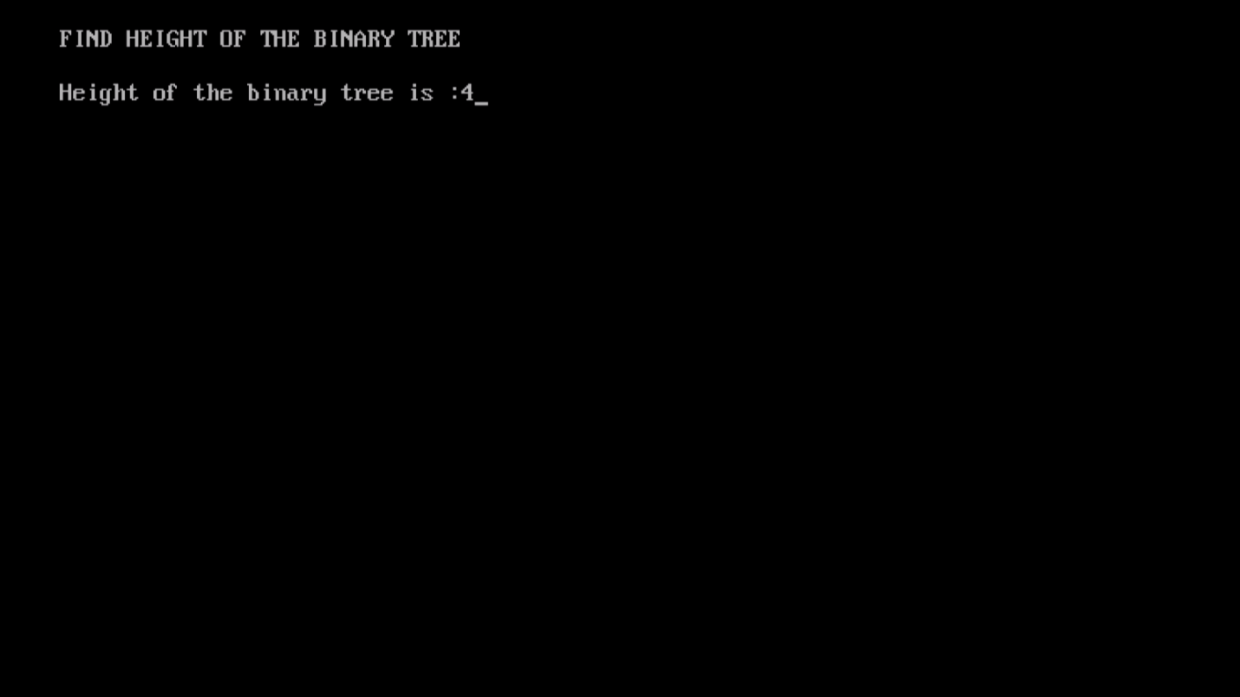

**//This code was contributed by K.Vijeyandrian MCA Section ’B’**